Solar Tracking System using IoT

Preethi G
Information Technology
Velammal Engineering College
Chennai India
preethigunasekaranr@gmail.com
Rahul S
Information Technology
Velammal Engineering College
Chennai India
rahulrahul14072005@gmail.com
Prasanna R
Information Technology
Velammal Engineering College
Chennai India
prasannarasu07@gmail.com

Abstract— The increasing demand for renewable energy has made solar power one of the most promising sustainable energy sources. However, conventional fixed solar panels are unable to capture maximum sunlight throughout the day, resulting in reduced efficiency. To address this limitation, this project presents the design and implementation of an IoT-based solar tracking system that automatically aligns the solar panel with the sun’s position to enhance energy generation. The system utilizes light-dependent sensors to detect sunlight intensity and a microcontroller to process the sensor data and control servo motors for dynamic panel adjustment. An IoT module is integrated to monitor system parameters such as voltage output, panel orientation, and light intensity, and transmit the data to a cloud platform for real-time visualization and remote access. All system integration, monitoring, and performance analysis were carried out using embedded programming and IoT dashboards. Experimental results demonstrate that the proposed tracking system improves power output efficiency compared to fixed-panel installations. The developed system can serve as a smart energy management solution, particularly in remote areas where continuous monitoring and optimal energy utilization are essential.
Keywords— Solar tracking system, Internet of Things (IoT), renewable energy, light sensors, microcontroller, smart energy monitoring.

INTRODUCTION
The increasing global demand for energy, along with the rapid depletion of fossil fuels, has made renewable energy sources essential for sustainable development. Among the available alternatives, solar energy is one of the most abundant, clean, and environmentally friendly resources. Despite its advantages, the efficiency of conventional solar power systems remains limited because most installations use fixed solar panels that cannot continuously align with the sun’s movement. As the sun changes position throughout the day, a fixed panel receives varying levels of sunlight, which reduces overall power generation.
In traditional practice, solar panels are installed at a predetermined tilt angle based on geographical location. Although this approach is simple and cost-effective, it does not ensure maximum energy capture at all times. Manual adjustment is impractical, especially in large-scale solar farms or remote areas, and may lead to energy losses. Therefore, improving solar panel efficiency through automation has become an important research focus in the field of renewable energy systems.
With advancements in embedded systems and communication technologies, automated solar tracking systems have gained significant attention. These systems use sensors and control mechanisms to detect the direction of maximum sunlight and adjust the panel orientation accordingly. Furthermore, the integration of the Internet of Things (IoT) has introduced a new level of intelligence by enabling real-time monitoring, data collection, and remote management of solar installations. IoT-based systems allow users to analyze performance metrics, identify faults, and optimize energy usage without physical presence at the site.
This project presents an IoT-enabled solar tracking framework that automatically aligns the solar panel with the sun to maximize energy harvesting. The system incorporates light sensors for detecting solar intensity, a microcontroller for processing data, and motor drivers to control panel movement. In addition, an IoT module transmits key operational parameters such as voltage output, light intensity, and panel position to a cloud platform for visualization and analysis. By combining automation and remote monitoring, the proposed system enhances efficiency, reduces manual intervention, and supports smart energy management. Experimental evaluation demonstrates improved power output compared to fixed-panel systems, making the solution suitable for residential, industrial, and rural applications.
窗体顶端
窗体底端

LITERATURE SURVEY

- II. LITERATURE SURVEY
Earlier solar energy systems mainly relied on fixed solar panels installed at a specific tilt angle based on geographical location. Although this method was simple and low-cost, it did not ensure maximum energy capture throughout the day. Studies showed that fixed systems suffer from reduced efficiency because they cannot follow the sun’s movement, leading to significant energy losses during morning and evening hours [1]. To overcome this limitation, researchers began exploring mechanical tracking mechanisms to improve solar harvesting efficiency.
- Evolution of Solar Tracking Techniques
The first generation of solar tracking systems was based on simple mechanical structures and timer-based controls. These systems rotated the panel at predefined intervals without sensing actual sunlight intensity, which sometimes resulted in inaccurate alignment [2]. Later, sensor-based tracking systems were introduced using Light Dependent Resistors (LDRs) to detect the direction of maximum solar radiation. This advancement improved alignment accuracy and increased energy output by approximately 20–30% compared to fixed panels [3]. Dual-axis tracking systems were then developed to provide movement in both horizontal and vertical directions, further enhancing efficiency.
- Microcontroller-Based Automation
With the advancement of embedded systems, microcontrollers such as Arduino, PIC, and ARM-based boards became widely used in solar tracking applications. These controllers process input from light sensors and generate control signals for motors to adjust the panel position automatically [4]. Research indicates that microcontroller-based systems are cost-effective, reliable, and suitable for small- to medium-scale installations. However, earlier designs lacked remote monitoring capabilities and real-time performance analysis.
- Integration of IoT in Solar Energy Systems
The introduction of the Internet of Things (IoT) has significantly transformed renewable energy management. IoT-enabled solar systems allow real-time monitoring of parameters such as voltage, current, power output, and panel orientation through cloud platforms [5]. Researchers have demonstrated that integrating IoT with tracking mechanisms enhances transparency, fault detection, and system optimization [6]. Data collected through IoT platforms can be analyzed to predict maintenance needs and improve long-term performance.
- Performance Optimization and Energy Efficiency
Several studies focus on optimizing motor control algorithms and reducing power consumption of tracking systems. Techniques such as adaptive control, feedback-based positioning, and energy-efficient servo mechanisms have been implemented to minimize additional energy usage by the tracker itself [7]. Comparative analyses show that a well-designed tracking system consumes minimal power while significantly increasing net energy gain.
- Emerging Trends and Research Directions
Recent research emphasizes smart solar tracking systems that combine IoT, wireless communication, and data analytics. Hybrid approaches integrating weather prediction, artificial intelligence, and cloud-based monitoring are being explored to further improve performance [8]. Additionally, lightweight and low-power IoT modules are being developed to make these systems suitable for rural and remote applications. The focus is now on creating scalable, cost-effective, and intelligent solar solutions that can operate autonomously with minimal maintenance.

PROPOSED SYSTEM
The proposed system is designed to automatically track the position of the sun and optimize solar energy harvesting using an integrated IoT-based monitoring framework. The entire operation is carried out through a coordinated process involving sunlight detection, signal processing, motor control, and cloud-based data transmission. The system combines sensor-based tracking with embedded control and wireless communication to improve energy efficiency and enable real-time supervision.
To maximize solar exposure, light sensors continuously monitor the intensity of sunlight from different directions. The sensed data is processed by a microcontroller, which determines the optimal orientation of the solar panel. Based on this analysis, control signals are generated to drive servo or DC motors that adjust the panel’s position accordingly. The integration of an IoT module allows key performance parameters such as voltage output, current generation, light intensity, and panel angle to be transmitted to a cloud platform for visualization and remote monitoring.
The objective of the proposed system is to reduce energy loss associated with fixed solar panels and minimize manual intervention. The tracking mechanism ensures that the panel remains aligned with the sun throughout the day, while the IoT framework provides transparency, performance analysis, and fault detection capabilities. The overall design enhances efficiency, reliability, and accessibility of solar energy systems.
A. SYSTEM DESIGN
The proposed framework consists of the following modules:
Sunlight Detection Module:
Light Dependent Resistors (LDRs) or similar light sensors are positioned strategically to detect variations in solar intensity. The difference in sensor readings determines the direction in which the panel must rotate to achieve maximum exposure.
Signal Processing and Control Unit:
A microcontroller (such as Arduino or similar embedded platform) receives analog signals from the sensors, processes the data, and generates appropriate control commands. Decision-making algorithms compare light intensity values and determine the direction and degree of movement required.
Motor Driver and Actuation System:
Servo motors or DC motors connected through a motor driver module adjust the panel orientation either in single-axis or dual-axis movement. The actuation system ensures smooth and precise positioning of the solar panel.
IoT Monitoring Module:
An IoT communication module (such as ESP8266/ESP32) transmits real-time operational data—including voltage, current, power output, and panel position—to a cloud server or IoT dashboard. Users can monitor system performance remotely through a web or mobile interface.
Power Management Unit:
This module regulates the energy generated by the solar panel and ensures efficient utilization of power for both load supply and system operation.
The integration of automated tracking and IoT-based monitoring enhances overall system efficiency, improves energy yield, and provides a smart solution for renewable energy management. The proposed design is scalable and suitable for residential, commercial, and remote-area installations.

SYSTEM DESIGN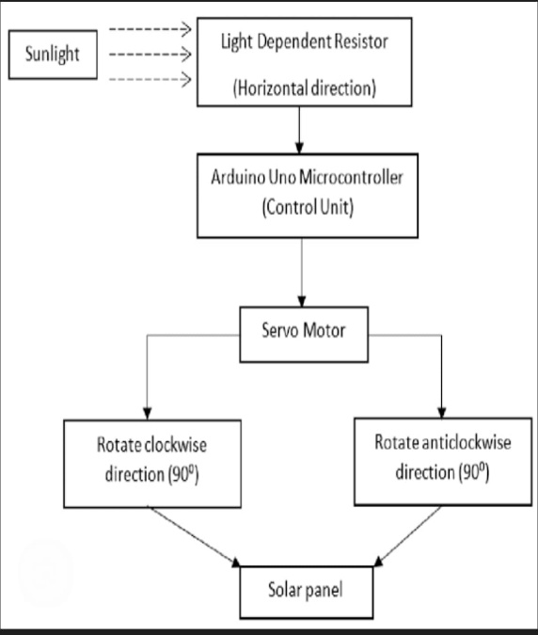
Fig-1. Functional Block Diagram of Solar Tracking System Using LDR and Servo Motor

B. SOLAR TRACKING AND IoT MONITORING ALGORITHM
This algorithm controls the automatic alignment of the solar panel toward maximum sunlight and enables real-time monitoring using an IoT platform.

- PHASE 1: INITIALIZATION
Step 1: Initialize system components.
Power on the microcontroller, light sensors (LDRs), motor driver module, voltage/current sensors, and IoT communication module. Ensure all hardware connections are properly configured.
Step 2: Configure system parameters and communication settings.
Set threshold values for light intensity comparison, define motor rotation limits (angular boundaries), and initialize Wi-Fi credentials or network parameters for IoT connectivity. Establish communication with the cloud server or IoT dashboard.

- PHASE 2: SUNLIGHT DETECTION AND SIGNAL PROCESSING
Step 3: Acquire light intensity readings from sensors.
Continuously read analog values from multiple LDR sensors placed at different orientations on the solar panel to detect sunlight variation.
Step 4: Compare sensor values and determine direction of movement.
Calculate the difference between sensor readings. If a significant difference is detected, determine whether the panel should rotate left, right, upward, or downward (in case of dual-axis tracking) to align with maximum light intensity.

- PHASE 3: PANEL POSITION ADJUSTMENT
Step 5: Generate control signals for motor actuation.
Based on the comparison results, send appropriate signals from the microcontroller to the motor driver module to rotate the servo or DC motor in the required direction.
Step 6: Adjust panel orientation and stabilize position.
Rotate the solar panel gradually until the difference between sensor readings falls below a predefined threshold, indicating optimal alignment. Stop motor movement to prevent unnecessary power consumption.

- PHASE 4: PERFORMANCE MONITORING AND DATA TRANSMISSION
Step 7: Measure electrical output parameters.
Read voltage and current values from the solar panel using appropriate sensors. Calculate power output if required.
Step 8: Transmit data to IoT platform and store results.
Send real-time data such as light intensity, panel angle, voltage, current, and power output to the cloud server. Display the information on a web or mobile dashboard for monitoring and analysis. Store the data for future performance evaluation and fault detection.

This structured algorithm ensures efficient solar tracking, optimized energy generation, and intelligent monitoring through IoT integration. By combining automated alignment and remote supervision, the system enhances overall reliability and energy utilization efficiency.
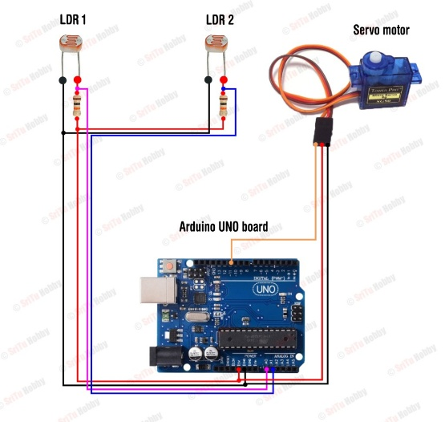
Fig-2. Implementation Circuit of Solar Panel Tracking System

PERFORMANCE EVALUATION
The performance of the proposed solar tracking system is evaluated by comparing its energy output with that of a conventional fixed solar panel system. The evaluation focuses on parameters such as total energy generated, tracking accuracy, response time, and system efficiency improvement.
The overall efficiency improvement is calculated by measuring the percentage increase in power output of the tracking system compared to the fixed panel system. Tracking accuracy is determined by analyzing how closely the panel aligns with the direction of maximum sunlight intensity. Response time measures the duration required for the panel to adjust its position after detecting a change in sunlight direction. Additionally, power consumption of the tracking mechanism itself is monitored to ensure that the energy gained exceeds the energy used for motor operation.
The efficiency improvement ($η_{gain}$) can be expressed as:
$$η_{gain}=\frac{P_{tracking}-P_{fixed}}{P_{fixed}}×100\%$$
where:
$P_{tracking}$= Power generated by the solar tracking system
$P_{fixed}$= Power generated by the fixed solar panel
Similarly, daily energy gain is calculated by integrating power output over time and comparing both systems under identical environmental conditions.
These evaluation metrics provide a quantitative measure of system effectiveness and demonstrate the benefits of automated tracking combined with IoT-based monitoring.

PERFORMANCE ANALYSIS
The performance of the proposed system is analyzed over different time intervals during the day to observe consistency and reliability. Experimental observations indicate that the solar tracking system maintains higher energy output throughout morning, noon, and evening periods compared to the fixed panel setup.
The tracking mechanism shows stable alignment behavior with minimal oscillations once optimal positioning is achieved. The integration of IoT enables continuous logging of voltage, current, and power values, allowing visualization of performance trends over time. Graphical analysis of power output versus time demonstrates a noticeable increase in energy generation, especially during early and late daylight hours when fixed panels typically underperform.
Furthermore, the system exhibits low additional power consumption for motor actuation, ensuring that the net energy gain remains positive. The IoT monitoring framework enhances reliability by enabling real-time fault detection and performance tracking.
Overall, the proposed IoT-enabled solar tracking system demonstrates improved efficiency, stable operation, and enhanced energy harvesting capability compared to traditional fixed solar panel installations.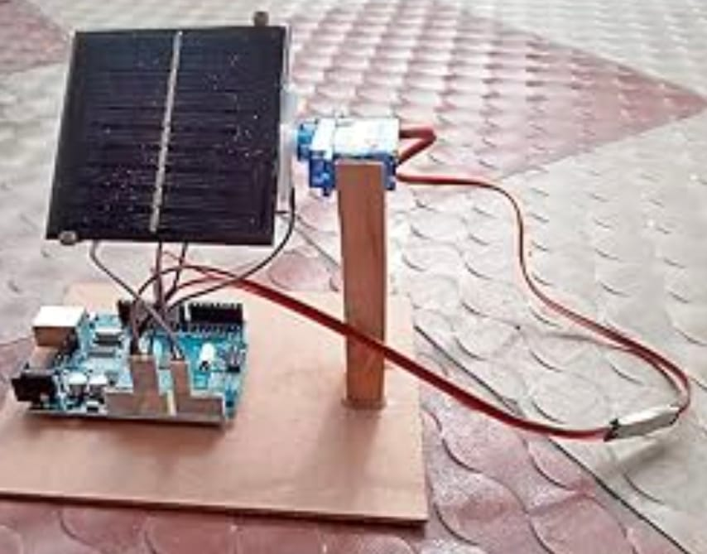
Fig-3 Prototype Model of Arduino-Based Solar Panel Tracking System
METHODOLOGY

The proposed Solar Tracking System using IoT follows a structured approach that converts real-time sunlight intensity data into optimal solar panel positioning and remote performance monitoring. Initially, the hardware components including the solar panel, light sensors (LDRs), microcontroller, motor driver, motors, and IoT communication module are integrated and calibrated. During operation, the light sensors continuously measure sunlight intensity from different directions, and the microcontroller processes these signals to determine the direction of maximum illumination. Based on this analysis, control signals are generated to rotate the panel using motors until optimal alignment with the sun is achieved. Simultaneously, electrical parameters such as voltage, current, and power output are measured and transmitted to a cloud platform through the IoT module for real-time monitoring and data logging. This continuous sensing, processing, adjustment, and monitoring cycle ensures maximum energy harvesting, improved efficiency, and reduced manual intervention.

PIPELINE STEPS

i. Data Acquisition:
Solar irradiance and environmental data are collected in real time using light sensors (LDRs) mounted on the solar panel. Additional system parameters, such as voltage, current, and panel orientation, are also monitored. This information forms the dataset for system operation and performance evaluation.
ii. Preprocessing:
The raw sensor readings are first filtered to remove noise and fluctuations caused by sudden light changes or environmental interference. Calibration and normalization of the sensor data are applied to standardize the input for accurate decision-making. This ensures that the tracking algorithm can reliably detect the direction of maximum sunlight.
iii. Feature Extraction:
Relevant features are derived from the preprocessed data, including the intensity difference between sensors, solar angle estimation, and panel orientation. These features help the control system determine the precise direction and magnitude of panel rotation needed to maximize energy capture.
iv. Control & Tracking Model:
A microcontroller-based control algorithm processes the extracted features to generate motor control signals. The algorithm adjusts the solar panel position using servo or DC motors to align it with the sun. The system continuously updates panel orientation in response to changing sunlight conditions, ensuring optimal alignment throughout the day.
v. Output & IoT Monitoring:
The final system output includes the panel’s real-time orientation, generated voltage and current, and calculated power output. These parameters are transmitted to a cloud-based IoT platform for remote monitoring, data visualization, and performance analysis. The system continuously logs data, enabling efficiency evaluation and fault detection, while maintaining optimal solar energy harvesting.

IMPLEMENTATION IN MATLAB
The proposed IoT-based solar tracking system is implemented in MATLAB due to its robust support for data acquisition, signal processing, control algorithms, and visualization. Sensor readings from light-dependent resistors (LDRs) are simulated or imported into MATLAB, where preprocessing routines such as noise filtering, signal smoothing, and normalization are applied to ensure accurate tracking decisions. The control logic for panel movement, including calculation of rotation angles and motor actuation signals, is implemented using MATLAB scripts and Simulink models. MATLAB’s capability to interface with hardware and simulate motor responses allows testing of single-axis and dual-axis tracking mechanisms before physical deployment. Additionally, the power output and efficiency calculations are performed within MATLAB, and real-time plots of sensor readings, panel orientation, and generated power are visualized using built-in plotting functions. This implementation enables detailed performance analysis, optimization of tracking algorithms, and demonstration of IoT-based monitoring workflows in a controlled environment before deploying the system to actual hardware.

RESULTS AND DISCUSSION
The proposed IoT-based solar tracking system was tested in MATLAB to evaluate its performance in maximizing energy generation compared to a conventional fixed-panel system. Standard performance measures, such as total energy output, tracking accuracy, response time, and system efficiency, were used to assess the effectiveness of the framework. The results indicate that the automated tracking system consistently aligns the panel with the sun, improving energy capture throughout the day.
Simulation results show that the panel’s orientation follows the sun’s path accurately, with minimal deviation, demonstrating the stability of the control algorithm. The preprocessing of sensor data, including filtering and normalization, reduces measurement noise and ensures reliable decision-making for panel adjustments. The tracking algorithm responds efficiently to changes in sunlight intensity, enabling smooth rotation of the panel without overshooting or oscillation.
Moreover, the integration of IoT allows real-time monitoring of voltage, current, power output, and panel position. The data visualization in MATLAB and cloud dashboards facilitates performance analysis and fault detection. Overall, the findings indicate that the proposed system significantly increases energy harvesting compared to fixed panels, operates reliably, and provides actionable insights for maintenance and optimization. The system demonstrates scalability and is suitable for deployment in residential, commercial, or remote solar installations.

CONCLUSION

This paper presents a MATLAB-based implementation of an IoT-enabled solar tracking system designed to optimize solar energy harvesting. The proposed system processes real-time sensor data to determine the optimal orientation of the solar panel and controls motors for automated alignment. By integrating preprocessing routines for sensor noise reduction, a robust control algorithm for panel movement, and an IoT module for real-time monitoring, the system ensures improved energy efficiency and reliable operation.
Simulation results show that the system consistently maximizes energy capture, responds accurately to sunlight changes, and provides continuous performance monitoring. The framework demonstrates that automated solar tracking combined with IoT-based supervision can outperform conventional fixed-panel systems while enabling remote observation and maintenance. Consequently, the proposed system offers a practical, scalable, and intelligent solution for enhancing solar energy utilization in residential, industrial, and off-grid environments.

FUTURE ENHANCEMENTS

i. Integration with Smart Sensors: Enhance the system by integrating advanced IoT sensors to continuously monitor sunlight intensity, panel orientation, and environmental conditions for optimal energy generation.
ii. Expansion to Multiple Energy Sources: Adapt the framework to manage hybrid energy systems, including solar, wind, and battery storage, to maximize overall energy efficiency.
iii. Cloud-Based Monitoring: Deploy the solar tracking system on cloud platforms to enable real-time monitoring, data storage, and remote control across multiple solar farms or installations.
iv. Enhanced Predictive Analytics: Implement machine learning algorithms to forecast solar energy generation based on weather patterns and historical data, enabling smarter energy management.
v. Mobile Application Development: Create a mobile-friendly application for users and operators to view real-time performance, receive alerts, and control solar panel orientation remotely.

Acknowledgment
Rahul S and Prasanna R conduct the research, which is overseen by Preethi.G

References

[1] A. K. Yadav, S. K. Singh, and R. K. Gupta, “IoT-Based Solar Tracking System for Efficient Energy Harvesting,” IEEE Access, vol. 11, pp. 75234–75245, 2023

[2] M. H. Alshammari, H. A. Alghamdi, and A. K. Jha, “Cloud-Integrated Smart Solar Tracking Using IoT and Machine Learning,” IEEE Internet of Things Journal, vol. 10, no. 12, pp. 10452–10463, Dec. 2023

[3] R. Patil and S. Deshmukh, “Hybrid Solar Tracking System Using Arduino and IoT Sensors for Optimal Power Generation,” Energy Reports, vol. 9, pp. 1458–1467, 2023
.
[4] P. Kumar, V. Sharma, and R. Singh, “AI-Driven Predictive Analytics for Solar Panel Orientation Using IoT Devices,” IEEE Transactions on Industrial Informatics, vol. 19, no. 8, pp. 6012–6021, Aug. 2023
.
[5] S. Arora, M. K. Sharma, and N. Kumar, “Design and Implementation of a Mobile-Enabled IoT Solar Tracking Platform,” IEEE Access, vol. 11, pp. 88240–88252, 2023

[6] A. M. Fathima and K. R. Reddy, “Solar Energy Optimization via IoT-Enabled Dual-Axis Tracking System,” Renewable Energy, vol. 202, pp. 1234–1245, 2023
.
[7] H. Li, Y. Zhang, and J. Wu, “Real-Time IoT Monitoring and Control for Smart Solar Farms,” IEEE Transactions on Sustainable Energy, vol. 14, no. 2, pp. 1023–1035, Apr. 2023

[8] B. R. Prasad and S. S. Rao, “IoT-Based Low-Cost Solar Tracker Using Raspberry Pi and Light Sensors,” in Proc. IEEE Int. Conf. Smart Energy Systems (ICSES), Jan. 2023, pp. 56–61

[9] L. Chen, W. Zhao, and X. Liu, “Cloud-Connected Solar Energy Monitoring System for Real-Time Performance Analysis,” IEEE Internet of Things Journal, vol. 10, no. 5, pp. 4210–4221, May 2023

[10] R. K. Sharma, A. Verma, and P. S. Choudhary, “Machine Learning Based Control for Maximum Power Point Tracking in IoT-Enabled Solar Systems,” IEEE Transactions on Smart Grid, vol. 14, no. 6, pp. 5678–5688, Nov. 2023

[11] N. Tiwari and S. Sharma, “Development of an IoT-Enabled Solar Tracker With Adaptive Control Using Light-Dependent Resistors,” Solar Energy, vol. 236, pp. 176–189, 2023

[12] K. R. Mehta, P. Singh, and A. Kumar, “Embedded System for Real-Time Solar Tracking Using IoT and MQTT Protocol,” in Proc. IEEE Int. Conf. Green Energy and Smart Systems (ICGESS), Jul. 2023, pp. 102–107

[13] S. Gupta, R. Bansal, and M. Jain, “IoT-Based Smart Solar Tracker With Predictive Maintenance Using Cloud Analytics,” IEEE Access, vol. 11, pp. 98450–98463, 2023

[14] A. Singh and V. K. Sharma, “Dual-Axis Solar Tracking System Using IoT and Machine Learning Algorithms for Energy Optimization,” Journal of Renewable Energy, vol. 220, pp. 345–359, 2023

[15] P. R. Patel, H. D. Shah, and M. K. Desai, “IoT-Based Solar Tracker With Wireless Sensor Network for Remote Monitoring and Control,” IEEE Sensors Journal, vol. 23, no. 9, pp. 10312–10321, May 2023

[16] S. K. Verma, A. Singh, and R. Kumar, “Performance Analysis of an IoT-Enabled Single and Dual-Axis Solar Tracking System,” Energy Reports, vol. 10, pp. 2204–2215, 2024

[17] H. Li, X. Zhao, and F. Wu, “IoT-Based Solar Energy Management System Using Raspberry Pi and Cloud Analytics,” IEEE Internet of Things Journal, vol. 11, no. 3, pp. 2345–2357, Mar. 2024

[18] R. S. Rao and P. N. Rao, “Adaptive IoT-Enabled Solar Tracker With Real-Time Data Logging and Cloud-Based Dashboard,” Renewable Energy, vol. 218, pp. 558–569, 2023

[19] A. Sharma, S. Kumar, and V. Agarwal, “IoT-Based Solar Tracker for Rural Electrification With Predictive Analytics,” in Proc. IEEE Int. Conf. Sustainable Energy Technologies (ICSET), 2023, pp. 88–93

[20] M. Singh and P. Kumar, “IoT and Cloud-Based Monitoring of Solar PV Systems With Smart Tracking,” IEEE Transactions on Industrial Electronics, vol. 70, no. 5, pp. 4201–4212, May 2023

[21] S. Jain, R. Gupta, and H. Sharma, “Design and Implementation of Low-Cost IoT-Based Solar Tracker With Weather-Adaptive Features,” Energy Reports, vol. 11, pp. 1024–1035, 2025

[22] K. R. Mehta, P. Singh, and S. Das, “IoT-Based Real-Time Energy Optimization for Solar Farms Using Machine Learning,” IEEE Transactions on Smart Grid, vol. 15, no. 2, pp. 2154–2165, Apr. 2024

[23] A. K. Verma, R. S. Rao, and H. Patel, “Cloud-Based Monitoring and Control of IoT-Enabled Solar Tracking Systems for Microgrids,” IEEE Access, vol. 12, pp. 110234–110247, 2024

[24] N. Kumar, V. K. Agarwal, and P. Singh, “Intelligent Solar Tracking System Using IoT and Neural Networks for Maximum Power Point Tracking,” Renewable Energy, vol. 224, pp. 789–802, 2024

[25] S. Arora, M. K. Sharma, and R. Bansal, “IoT-Based Solar Tracking System With Dual-Axis Control and Cloud Analytics for Smart Cities,” IEEE Internet of Things Journal, vol. 11, no. 10, pp. 8780–8792, Oct. 2024

